**Metropolitan Branch Trail Design Build, South Segment**

**DC CONTRACT NO. DCKA-2016-C-0044**

**FAP No.: STP-2016 (060)**

CONSTRUCTION MANAGER’S

WEEKLY PROGRESS REPORT

01/31/2021 – 02/06/2021

Project Website: [www.metbranchtrail-forttotten.com](http://www.metbranchtrail-forttotten.com)

For Additional Trail Information Please see [www.metbranchtrail.com](http://www.metbranchtrail.com)

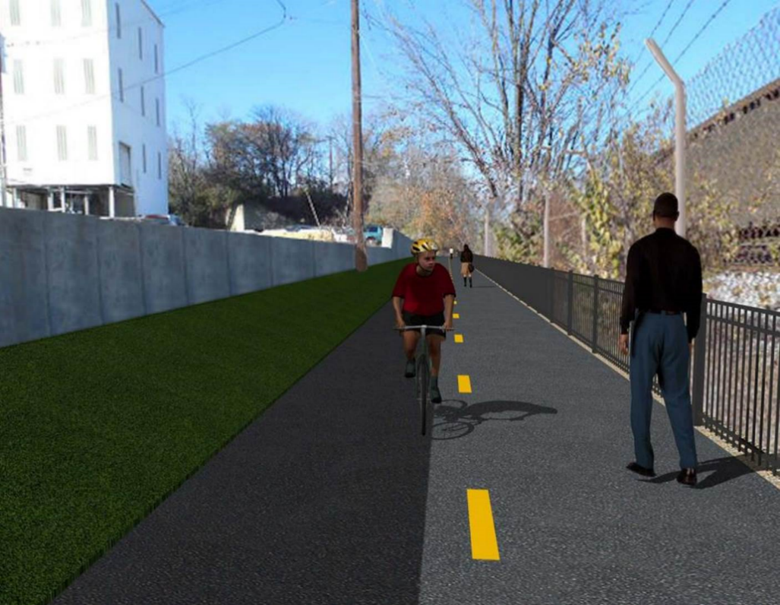

**Proposed Metropolitan Branch Trail**

**1. PROJECT DESCRIPTION**

The planned Metropolitan Branch Trail Project (“the Project”) consists of the design and construction of a new trail adjacent to CSX tracks and WMATA Red Line tracks along John McCormack Drive, adjacent to Fort Totten Metro Station, and on NPS property in NE, Washington D.C. The trail begins approximately 1500 feet south of Bates Road NE on the east side of John McCormack Drive NE, extending north along the WMATA and CSX tracks to the Fort Totten Metro Station tie in with First Place NE. An existing trail connection from Gallatin Road NE to the Fort Totten Metro Station will be reconstructed as a part of the Project.

The Project is 83.15% Federally-Funded and 16.85% District-Funded. Potomac Construction is the Design Build contractor.

Delon Hampton and Associates Chartered is providing Construction Management and Inspection services. Specific Construction Scope of Work includes:

* Provide mobilization and demobilization, provision and maintenance of Engineer’s field facilities, field layout, employee training, and other incidental work required for a quality, complete and finished product;
* Establishment and maintenance of vehicular and pedestrian traffic including signs, barricades and other transition devices; reconfiguring the devices in conjunction with changes in work areas; and their removal and disposal upon project completion, including restoration of disturbed areas;
* Clearing and grubbing, as required within the LOD;
* Removal of unsuitable material, excavation, and backfilling and pervious paving to construct a new trail;
* Protection of trees during construction;
* Provide ADA compliant trail connections and pedestrian ramps;
* Provide retaining walls as necessary to stay within the LOD and minimize property impacts following visual requirements specified for retaining walls on NPS property;
* Provide new permanent regulatory and wayfinding signs for the trail and all trail connection intersections;
* Provide road and trail pavement markings;
* Provide landscaping within the LOD for the Project including special requirements for landscaping on NPS property;
* Provide erosion and sediment control measures, storm water management facilities, including pervious asphalt pavement and bioretention facilities;
* Provide utility coordination, identification, locating, and protection of all utilities encountered during design and construction including relocation of Pepco poles along Aggregate Industries property; and
* Provide new WMATA security fencing between the trail and CSXT tracks.
* Remove existing sidewalk and widen sidewalk to 10’ along the west side of 1st place NE from Metropolitan Branch Trail to entrance to WMATA bus loop, on the west side.

**2. STATUS OF CONSTRUCTION / PROGRESS SUMMARY**

**Work performed this week:**

**Design**

* MBT Designer submitted Phase D 3-ring binder and 100% Plans to DDOT
* Stakeholders acceptance for Phase D Final Design Plans
* CSX is reviewing Phase D Means and Methods

**Construction:**

**Phase B**

* MPD Security Cameras is scheduled to be installed
* Lighting Level equipment to be installed

**Phase D**

* Excavated drainage trench
* Installed drainage pipes
* Constructed brick manhole
* Placed drainage pipes cradle concrete
* Placed concrete at electrical duct bank
* Cleaned electrical manholes ground rod openings
* CSX flagger’s operation and safety tool box talk

**CM Consultant:**

* Monitored construction progress, make sure all applicable inspections and testing were

Performed

* Reviewed Inspector Daily Reports
* Prepared CM Weekly Reports
* Attended DDOT PEPCO CM Aldridge Electric and PCCI Field Meeting
* Attended DDOT CM PCCI Pending Change Orders Discussion Meeting
* Updated Project Files
* Updated Project Webpage
* Updated documents in SharePoint
* Communication with the stakeholder in terms of submittals

**3. MEETINGS / PROJECT COORDINATION**

Tue 02/02/21 MBT Project Progress Meeting conference call was held 10:00 A.M.

Fri. 02/05/21 DDOT DHA PEPCO Aldridge Electric and PCCI Field Meeting

was held at 11:00 A.M.

Fri. 02/05/21 DDOT DHA PCCI Pending Change Orders Discussion Meeting

conference call was held 3:00 P.M.

.

**4. DAILY WORK PERFORMED**

Sun 01/31/21 No work performed.

Mon 02/01/21 Phase B – No work performed. Site covered with snow.

Phase B - Electrical Work – No work performed.

Phase D – No work performed. Site covered with snow.

Tue 02/02/21 Phase B – No work performed.

Phase B – Electrical Work – No work performed

Phase D – Site too wet. No work performed.

Wed 02/03/21 Phase B – No work performed.

Phase B – Electrical Work – No work performed.

Phase D – Cleaned site and removed snow on drainage structures and access ramp.

Thurs 02/04/21 Phase B – No work performed

Phase B – Electrical Work – No work scheduled

Phase D – Installed drainage pipes. Placed concrete cradle between manhole and inlet. Constructed drainage manholes.

Phase D – Electrical Work – Installed electrical conduits. Placed concrete at electrical duct bank trench.

Phase D – Electrical Work – Cleaned light poles base

Fri 02/05/21 Phase B – No work performed.

Phase B – Electrical work – No work scheduled

Phase D – Installed drainage pipes. Placed concrete cradle between manhole and inlet. Constructed drainage manholes.

Phase D – Electrical work – Cleaned ground rod openings in electrical manholes and make preparation for manholes installation

Sat 02/06/21 No work scheduled

**5. INSPECTION & MATERIAL TESTS PERFORMED**

|  |  |
| --- | --- |
| Jobsite Safety Inspection  Erosion and Sediment Control inspection  MOT Inspection  Compaction Test - Passed  Asphalt Material Testing  Concrete Material Testing – Pending results  **\*\* Note - Additional Material Test Results can be found on DDOT QA QC Material Division Tracking SharePoint website**. | Infiltration Tests  Dynamic Cone Penetration (DCP) Tests - Passed  Rebars Inspection - Ongoing |

**6. DBE PARTICIPATION SUMMARIES**

Potomac Construction (Contractor)

* DBE Goal for Contractor is 15%. To-date the Contractor has achieved 46% of their goal.

Delon Hampton & Associates (CM)

* DBE Goal for the CM is 10%. To-date the CM has achieved 58% of their Goal.

**7. ACCIDENTS / INCIDENTS**

None occurred on-site during this week.

**8. PHOTOS OF THE WORK PERFORMED**

**12. PHOTOS OF WORK PERFORMED THIS PERIOD**

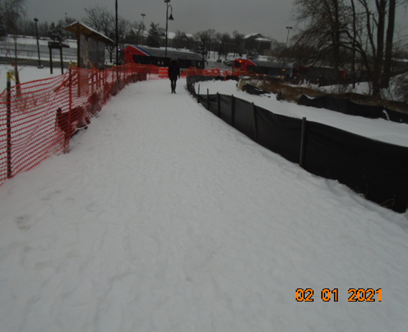

Phase B – No work performed

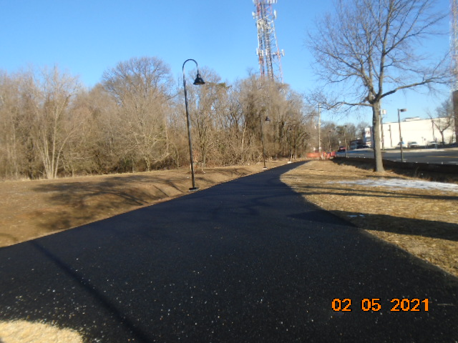

Phase B – No work performed

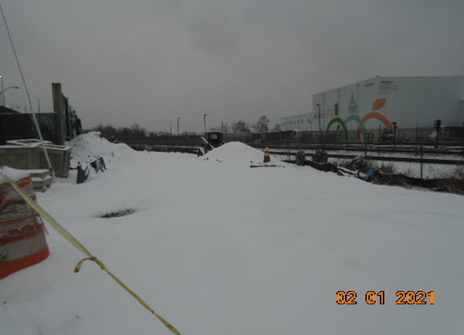

Phase D – Contractor canceled work due to snow

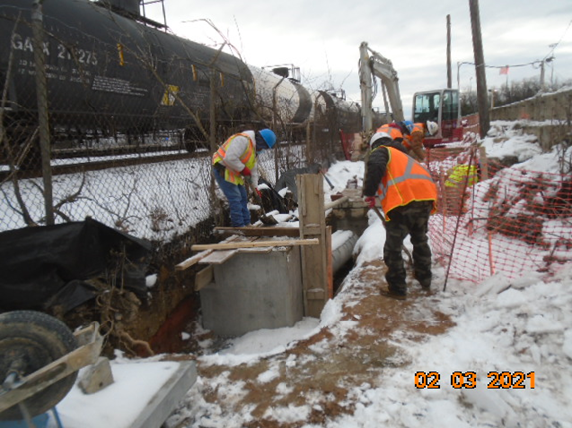

Phase D – Crew removing snow on drainage structure

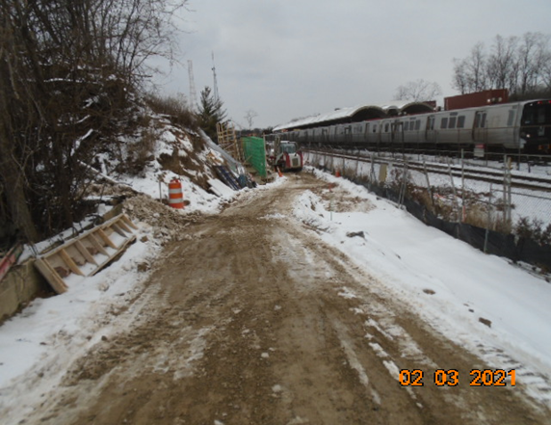

Phase D – Temporary access ramp cleaned

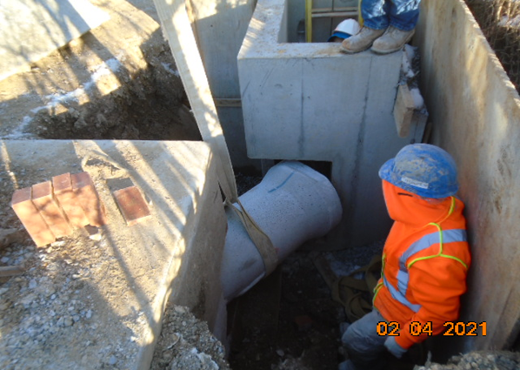

Phase D – Crew installing drainage pipe between drainage manholes

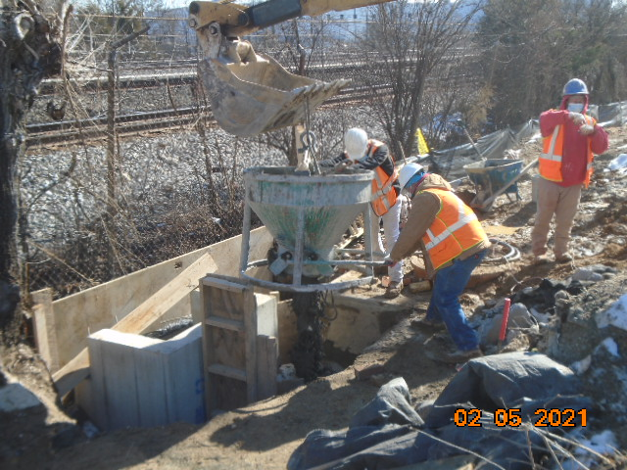

Phase D – Crew constructing placing drainage pipe cradle concrete

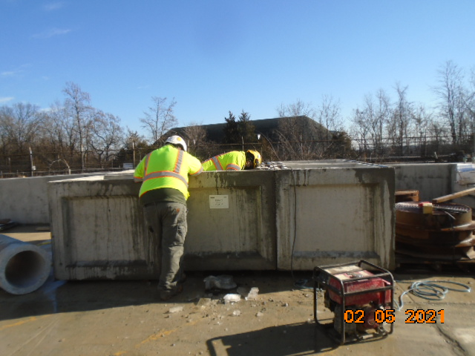

Phase D – Electrical crew cleaning up electrical manhole ground rod room