**Metropolitan Branch Trail Design Build, South Segment**

**DC CONTRACT NO. DCKA-2016-C-0044**

**FAP No.: STP-2016 (060)**

CONSTRUCTION MANAGER’S

WEEKLY PROGRESS REPORT

01/02/2022 – 01/08/2022

Project Website: [www.metbranchtrail-forttotten.com](http://www.metbranchtrail-forttotten.com)

For Additional Trail Information Please see [www.metbranchtrail.com](http://www.metbranchtrail.com)

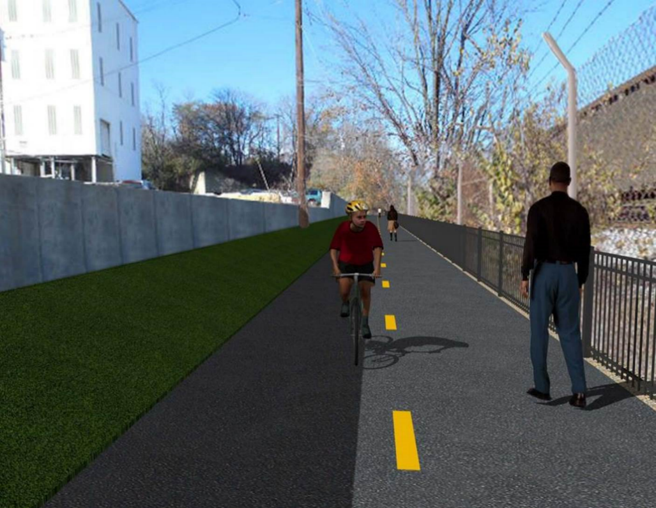

**Proposed Metropolitan Branch Trail**

**1. PROJECT DESCRIPTION**

The planned Metropolitan Branch Trail Project (“the Project”) consists of the design and construction of a new trail adjacent to CSX tracks and WMATA Red Line tracks along John McCormack Drive, adjacent to Fort Totten Metro Station, and on NPS property in NE, Washington D.C. The trail begins approximately 1500 feet south of Bates Road NE on the east side of John McCormack Drive NE, extending north along the WMATA and CSX tracks to the Fort Totten Metro Station tie in with First Place NE. An existing trail connection from Gallatin Road NE to the Fort Totten Metro Station will be reconstructed as a part of the Project.

This project is 83.15% Federally Funded and 16.85% Locally Funded. DDOT selected Potomac Construction Company, Inc. (PCCI) as the contractor and awarded the $8,555,000.00 contract on September 28, 2017. DDOT issued Notice to Proceed (NTP) with contract work to begin on October 31, 2017. A time extension approved on April 23, 2020 has set the substantial completion date to August 6, 2020. DDOT extended contract expiration date by 60 days from August 7, 2020 to October 6, 2020. A time extension approved on October 6, 2020 extended contract expiration date by 90 days from October 6, 2020 to January 5, 2021. A time extension approved on December 21, 2020 extended contract expiration date by 90 days from January 5, 2021 to April 5, 2021. A time extension approved on April 2, 2021 extended contract expiration date by 90 days from April 5, 2021 to July 4, 2021. A time extension approved on June 21, 2021 extended contract expiration date by ninety (90) days from July 6, 2021 to October 4, 2021.

Delon Hampton and Associates Chartered is providing Construction Management and Inspection services.

Specific Construction Scope of Work includes:

* Existing streetlights poles from the beginning point of the project south to Michigan Avenue shall have the existing luminaires replaced with new LED cobra head luminaires, see Section 16 of the Project Technical Provisions for details;
* Provide mobilization and demobilization, provision and maintenance of Engineer’s field facilities, field layout, employee training, and other incidental work required for a quality, complete and finished product;
* Establishment and maintenance of vehicular and pedestrian traffic including signs, barricades and other transition devices; reconfiguring the devices in conjunction with changes in work areas; and their removal and disposal upon project completion, including restoration of disturbed areas;
* Clearing and grubbing, as required within the LOD;
* Removal of unsuitable material, excavation, and backfilling and pervious paving to construct a new trail;
* Protection of trees during construction;
* Provide ADA compliant trail connections and pedestrian ramps;
* Provide retaining walls as necessary to stay within the LOD and minimize property impacts following visual requirements specified for retaining walls on NPS property;
* Provide new permanent regulatory and wayfinding signs for the trail and all trail connection intersections;
* Provide road and trail pavement markings;
* Provide landscaping within the LOD for the Project including special requirements for landscaping on NPS property;
* Provide erosion and sediment control measures, storm water management facilities, including pervious asphalt pavement and bioretention facilities;
* Provide utility coordination, identification, locating, and protection of all utilities encountered during design and construction including relocation of Pepco poles along Aggregate Industries property; and
* Provide new WMATA security fencing between the trail and CSXT tracks.
* Remove existing sidewalk and widen sidewalk to 10’ along the west, side of First Place NE from Metropolitan Branch Trail to entrance to WMATA bus loop, on the west side.

**2. STATUS OF CONSTRUCTION / PROGRESS SUMMARY**

**Work performed this week:**

**Design**

* 100 % Complete

**Construction:**

**Phase D**

* Excavated drainage trench
* Installed drainage pipes
* Backfilled and compacted drainage trench
* Removed WMATA Stair formwork
* Removed existing light pole foundations
* Installed electrical conduits at light pole foundation
* Contractor safety tool box talk

**CM Consultant:**

* Monitored construction progress, make sure all applicable inspections and testing were performed
* Reviewed Project Schedule
* Reviewed PCCI Monthly Invoice
* Prepared CM Weekly Report to post
* Prepared CM Weekly report to DDOT
* Updated Project Files
* Updated Project Logs
* Updated Project Webpage
* Updated documents in DHA SharePoint site
* Updated DDOT Sharepoint site
* Communication with PCCI and stakeholders in terms of submittals

**3. MEETINGS / PROJECT COORDINATION**

None during this week.

**4. DAILY WORK PERFORMED**

Sun 01/02/22 No work performed.

Mon 01/03/22 Phase D – No work performed. Snow day.

Phase D – Electrical work – No work performed. Snow day.

Tue 01/04/21 Phase D – Phase D – Removed WMATA Stair formwork. Cleaned snow from MBT

trail path. Excavated and graded trail path. Excavated drainage trench. Placed

bedding stone for drainage pipes. Installed drainage pipes. Backfilled and compacted

drainage trench.

Phase D – Electrical work – No work performed.

Wed 01/05/21 Phase D – Removed WMATA Stair formwork. Excavated and graded trail path. Excavated drainage trench. Placed bedding stone for drainage pipes. Installed drainage pipes. Backfilled and compacted drainage trench.

Phase D – Electrical work – No work performed.

Thurs 01/06/21 Phase D – Removed WMATA Stair formwork. Excavated and graded trail path.

Excavated drainage trench. Placed bedding stone for drainage pipes. Installed drainage pipes. Backfilled and compacted drainage trench.

Phase D – Electrical Work – Excavated and removed existing streetlight foundation.

Fri 01/07/21 Phase D – No work performed. Site too wet from overnight snow.

Phase D – Electrical Work – No work performed. Site too wet from overnight snow.

Sat 01/08/21 Phase D – No work scheduled.

**5. INSPECTION & MATERIAL TESTS PERFORMED**

|  |  |
| --- | --- |
| Jobsite Safety Inspection  Erosion and Sediment Control inspection  MOT Inspection  Compaction Test  Asphalt Material Testing  Concrete Material Testing – Results pending  **\*\* Note - Additional Material Test Results can be found on DDOT QA QC Material Division Tracking SharePoint website**. | Infiltration Tests  Dynamic Cone Penetration (DCP) Tests  Rebars Inspection |

**6. DBE PARTICIPATION SUMMARIES**

**Design**

* MBT Designer submitted Phase D 3-ring binder and 100% Plans to DDOT
* Stakeholders acceptance for Phase D Final Design Plans
* CSX is reviewing Phase D Means and Methods

**Construction:**

**Phase B**

* No work performed

**Phase D**

* Excavated drainage trench
* Installed and backfilled drainage pipes
* Constructed and backfilled drainage manholes
* Constructed retaining wall footings formwork
* Installed retaining wall footings rebars
* Placed retaining wall S2 footing concrete
* Installed temporary drainage pipes
* Installed silt fence
* CSX flagger’s operation and safety tool box talk

**CM Consultant:**

* Monitored construction progress, make sure all applicable inspections and testing were

Performed

* Attended site walk-through meeting with DDOT NPS and PCCI
* Reviewed Inspector Daily Reports
* Reviewed WMATA Invoice
* Prepared Change Order packages
* Prepared CM Weekly Reports
* Updated Project Files
* Updated Project Webpage
* Updated documents in SharePoint

**MS**

Potomac Construction Inc. (Contractor)

* DBE Goal for Contractor is 15%. To-date the Contractor has achieved 55% of their goal.

Delon Hampton & Associates (CM)

* DBE Goal for the CM is 10%. To-date the CM has achieved 102 % of their goal.

**7. ACCIDENTS / INCIDENTS**

None occurred during this week.

**8. PHOTOS OF THE WEEK**

**12. PHOTOS OF WORK PERFORMED THIS PERIOD**

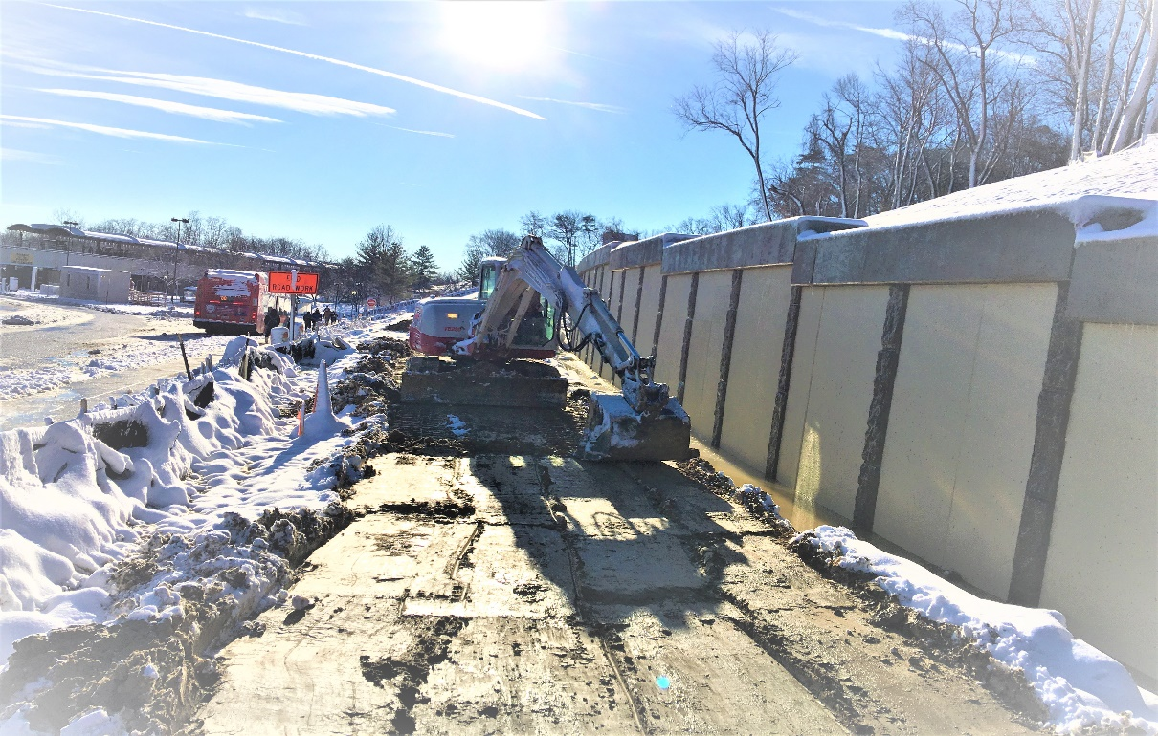

Phase D – Crew cleaning and grading the trail parth

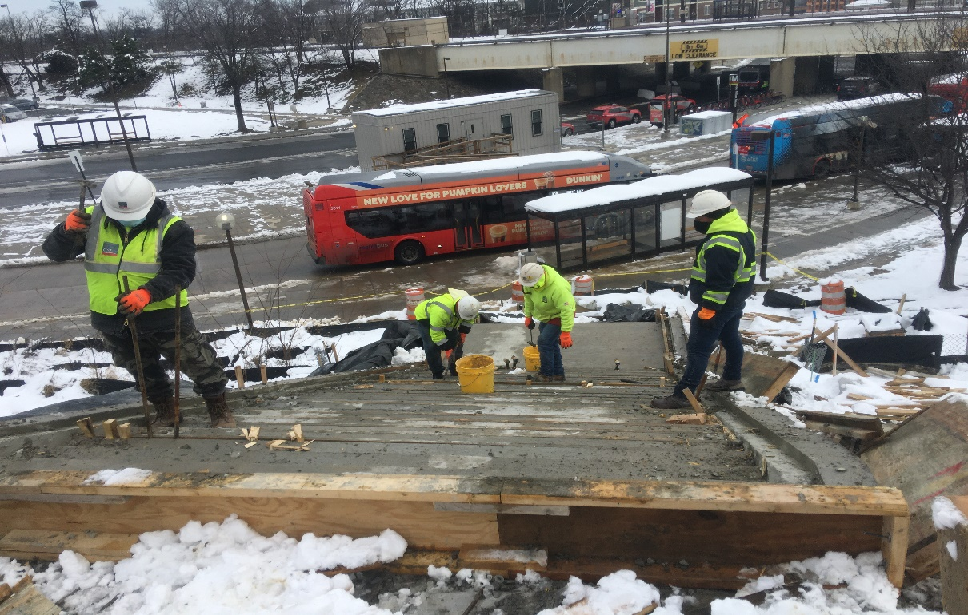

Phase D – Crew removing WMATA Stair formwork

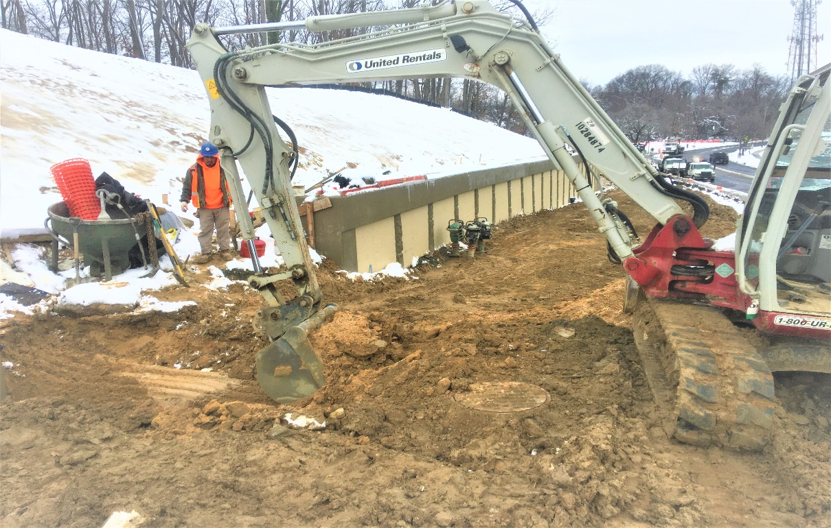

Phase D – Crew excavating drainage pipe trench

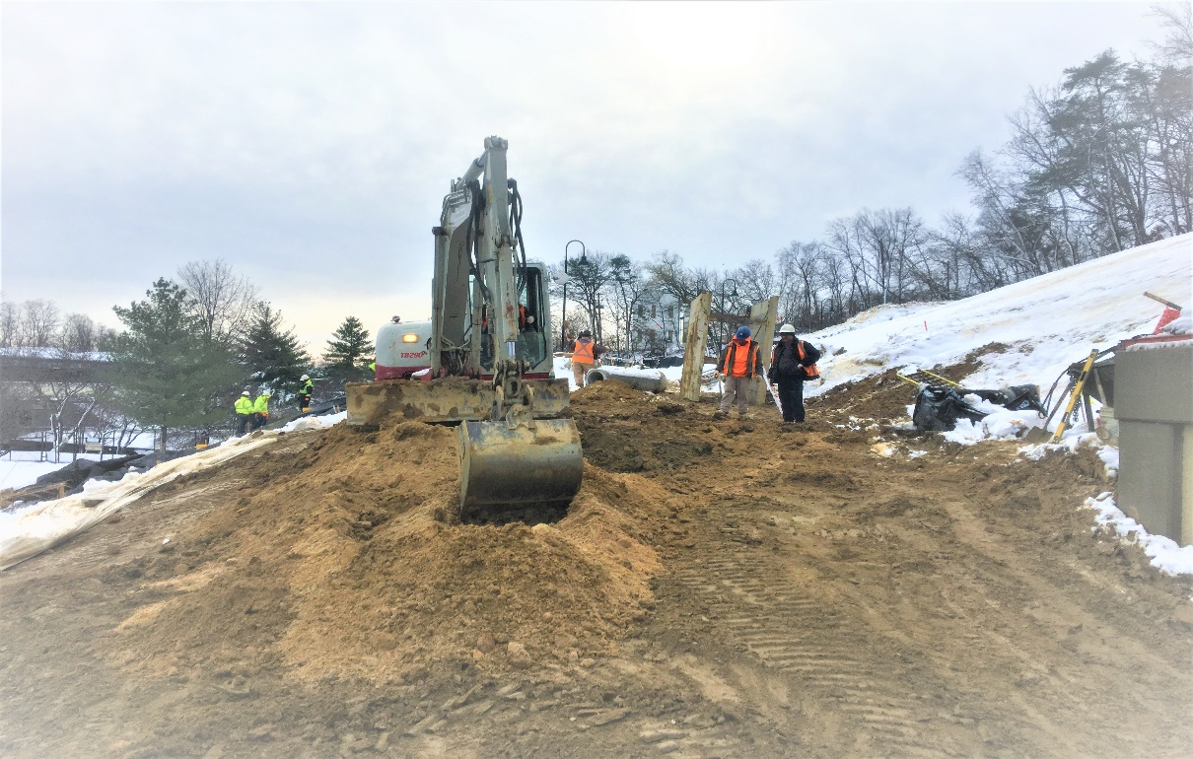

Phase D – Crew excavting MBT trail path

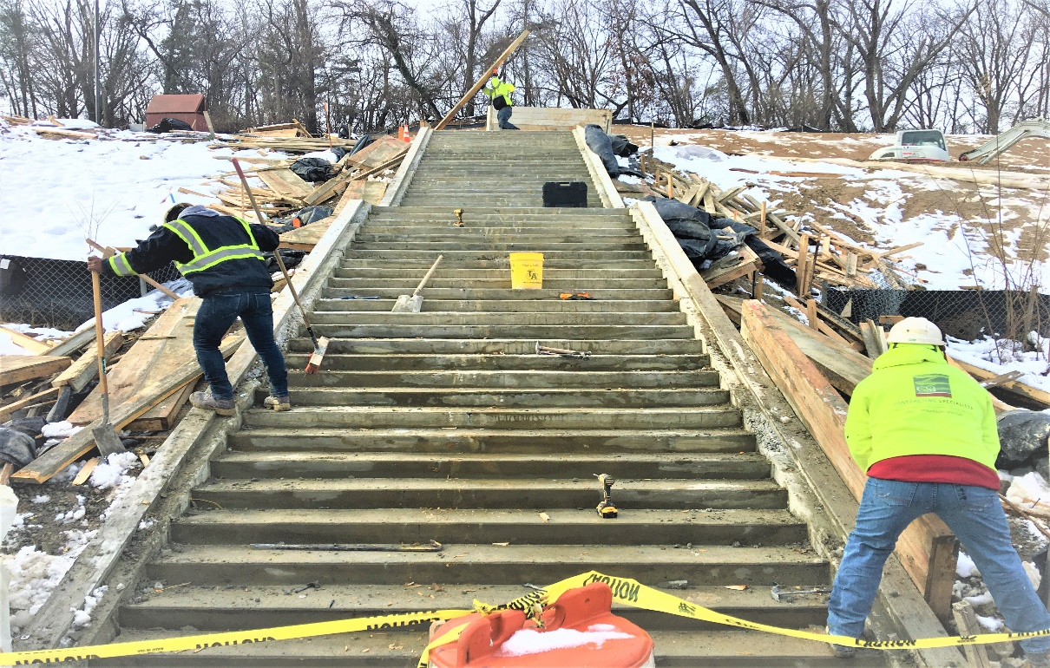

Phase D – Crew removing WMATA Stairs formwork

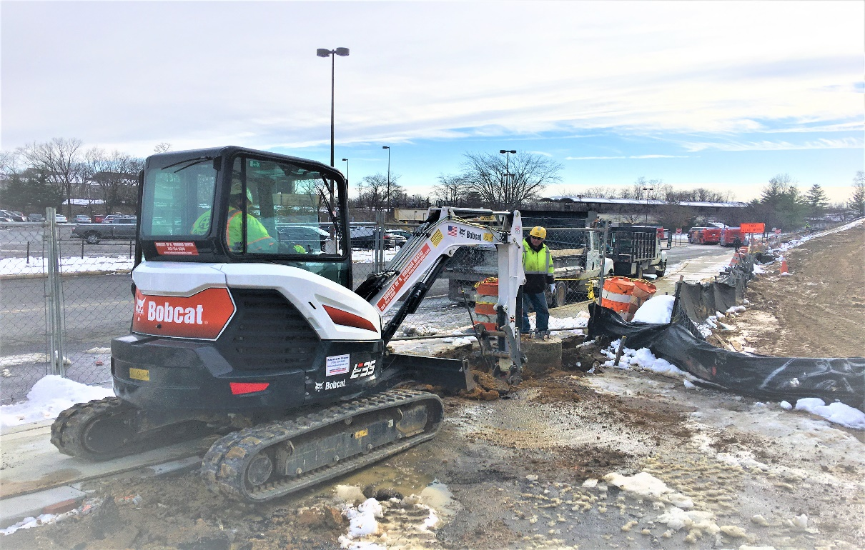

Phase D – Crew removing WMATA light pole foundation

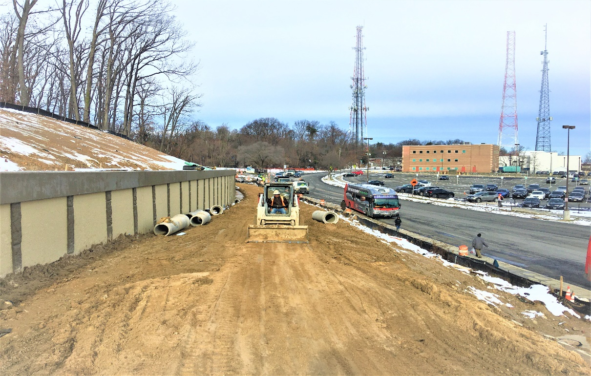

Phase D – Crew grading the trail path

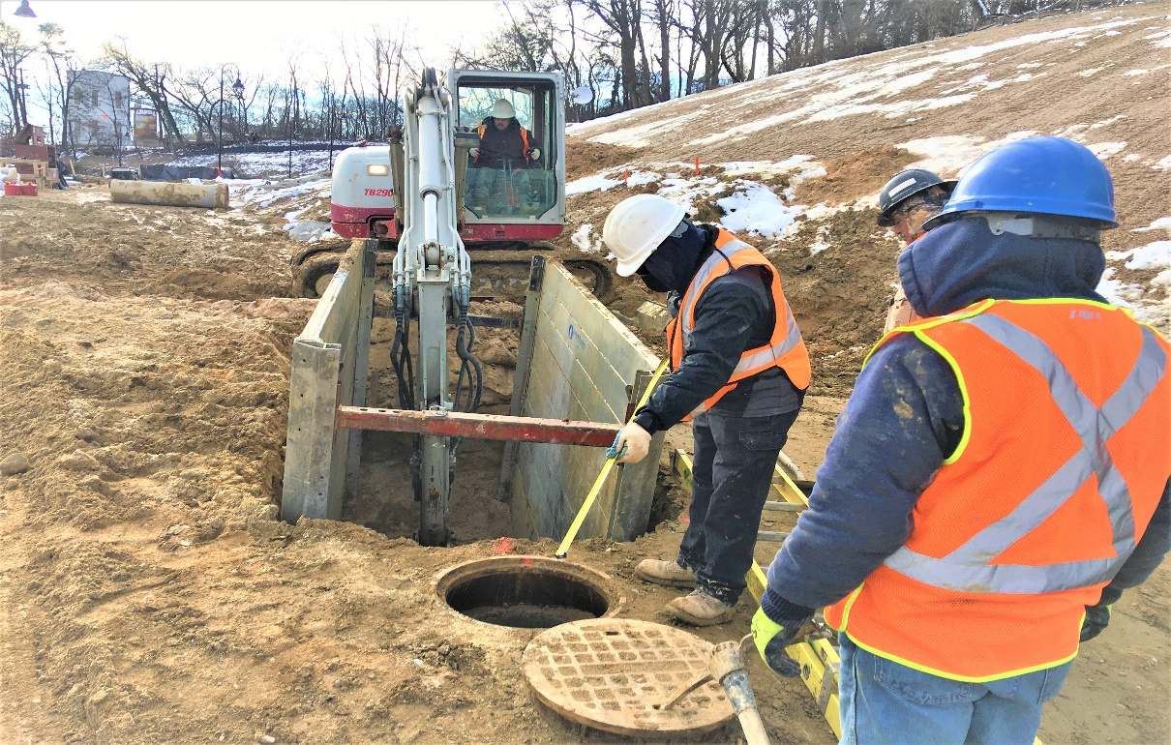

Phase D – Crew excavting drainage trench