Metropolitan Branch Trail Design Build, South Segment
DC CONTRACT NO. DCKA-2016-C-0044
FAP No.: STP-2016 (060)

CONSTRUCTION MANAGER’S
WEEKLY PROGRESS REPORT

12/27/2020 – 01/02/2021

Project Website: www.metbranchtrail-forttotten.com
For Additional Trail Information Please see www.metbranchtrail.com

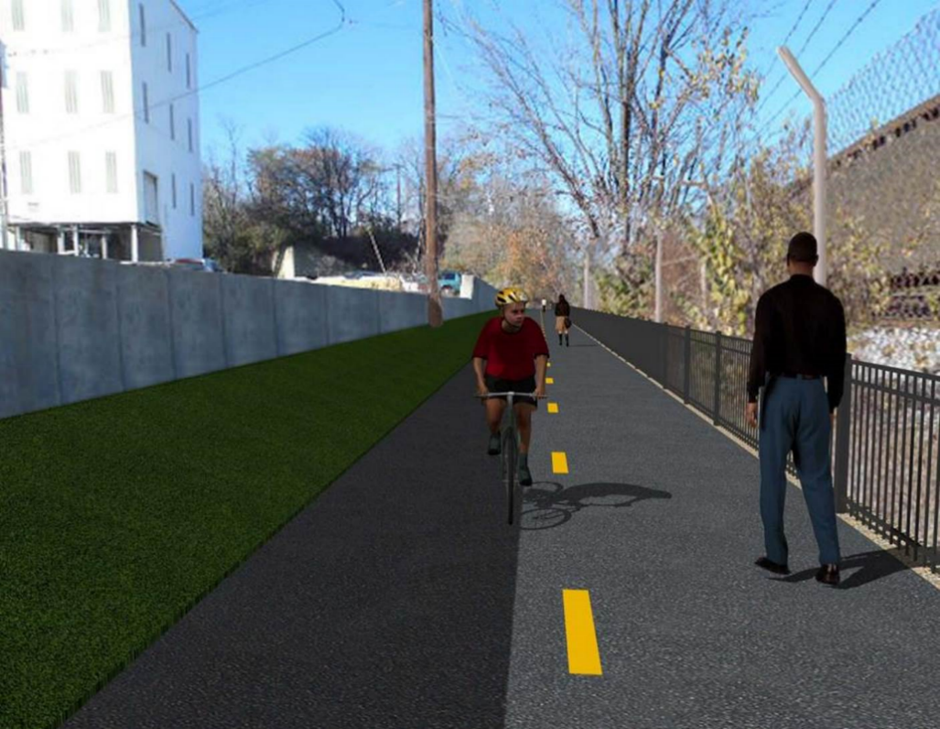

Proposed Metropolitan Branch Trail

1. PROJECT DESCRIPTION

The planned Metropolitan Branch Trail Project (“the Project”) consists of the design and construction of a new trail adjacent to CSX tracks and WMATA Red Line tracks along John McCormack Drive, adjacent to Fort Totten Metro Station, and on NPS property in NE, Washington D.C. The trail begins approximately 1500 feet south of Bates Road NE on the east side of John McCormack Drive NE, extending north along the WMATA and CSX tracks to the Fort Totten Metro Station tie in with First Place NE. An existing trail connection from Gallatin Road NE to the Fort Totten Metro Station will be reconstructed as a part of the Project.

The Project is 83.15% Federally-Funded and 16.85% District-Funded. Potomac Construction is the Design Build contractor.

Delon Hampton and Associates Chartered is providing Construction Management and Inspection services. Specific Construction Scope of Work includes:

- Provide mobilization and demobilization, provision and maintenance of Engineer’s field facilities, field layout, employee training, and other incidental work required for a quality, complete and finished product;
- Establishment and maintenance of vehicular and pedestrian traffic including signs, barricades and other transition devices; reconfiguring the devices in conjunction with changes in work areas; and their removal and disposal upon project completion, including restoration of disturbed areas;
- Clearing and grubbing, as required within the LOD;
- Removal of unsuitable material, excavation, and backfilling and pervious paving to construct a new trail;
- Protection of trees during construction;
- Provide ADA compliant trail connections and pedestrian ramps;
- Provide retaining walls as necessary to stay within the LOD and minimize property impacts following visual requirements specified for retaining walls on NPS property;
- Provide new permanent regulatory and wayfinding signs for the trail and all trail connection intersections;
- Provide road and trail pavement markings;
- Provide landscaping within the LOD for the Project including special requirements for landscaping on NPS property;
- Provide erosion and sediment control measures, storm water management facilities, including pervious asphalt pavement and bioretention facilities;
- Provide utility coordination, identification, locating, and protection of all utilities encountered during design and construction including relocation of Pepco poles along Aggregate Industries property; and
- Provide new WMATA security fencing between the trail and CSXT tracks.
- Remove existing sidewalk and widen sidewalk to 10’ along the west side of 1st place NE from Metropolitan Branch Trail to entrance to WMATA bus loop, on the west side.

2. STATUS OF CONSTRUCTION / PROGRESS SUMMARY

Work performed this week:

Design

- MBT Designer submitted Phase D 3-ring binder and 100% Plans to DDOT
- Stakeholders acceptance for Phase D Final Design Plans
- CSX is reviewing Phase D Means and Methods

Construction:

Phase B

- No work performed

Phase D

- Constructed drainage manholes
- Placed drainage pipes cradle concrete
- Installed retaining wall rebars
- Excavated retaining wall footings
- Stripped retaining wall formwork
- Shaft drilled retaining wall foundation
- Installed retaining wall foundation piles
- Placed shaft concrete
- Excavated drainage trench
- Installed drainage pipes
- Backfilled and compacted drainage trench
- Constructed brick manhole
- Installed silt fence
- CSX flagger’s operation and safety tool box talk

CM Consultant:

- Monitored construction progress, make sure all applicable inspections and testing were
Performed
- Reviewed Inspector Daily Reports
- Prepared CM Weekly Reports
- Updated Project Files
- Updated Project Webpage
- Updated documents in SharePoint
- Communication with the stakeholder in terms of submittals

3. MEETINGS / PROJECT COORDINATION

None for this week.

4. DAILY WORK PERFORMED

Sun 12/27/20 No work performed.
Mon 12/28/20 Phase B – No work performed.
Phase B - Electrical Work – No work scheduled.
Phase D – Excavated retaining wall footing concrete. Stripped retaining wall S2 footings formwork. Installed retaining wall S2 wall rebars. Constructed drainage manhole.
Tue 12/29/20 Phase B – No work performed
Phase B – Electrical Work – No work scheduled.
Phase D – Shaft drilled S2 wall foundation near the existing concrete encased electrical duct bank. Excavated drainage trench, placed bedding materials and installed drainage pipe. Backfilled and compacted drainage trench. Constructed brick manhole. Installed silt fence.
Wed 12/30/20 Phase B – No work performed
Phase B – Electrical Work – No work scheduled
Phase D – Shaft drilled S2 wall foundation near the existing concrete encased electrical duct bank. Installed retaining wall foundation piles. Placed retaining wall shafts concrete. Constructed brick manhole. Install silt fence.
Thurs 12/31/20 Phase B – No work performed
Phase B – Electrical Work – No work scheduled
Phase D – No work performed
Fri 01/01/21 Phase B – Holiday
Phase B – Electrical work – Holiday
Phase D – Holiday
Sat 02/02/21 No work scheduled

5. INSPECTION & MATERIAL TESTS PERFORMED

Jobsite Safety Inspection  Erosion and Sediment Control inspection  MOT Inspection  Compaction Test - Passed  Asphalt Material Testing  Concrete Material Testing – Pending results  ** Note - Additional Material Test Results can be found on DDOT QA QC Material Division Tracking SharePoint website. | Infiltration Tests  Dynamic Cone Penetration (DCP) Tests - Passed  Rebars Inspection - Passed
6. DBE PARTICIPATION SUMMARIES

Potomac Construction (Contractor)
- DBE Goal for Contractor is 15%. To-date the Contractor has achieved 46% of their goal.

Delon Hampton & Associates (CM)
- DBE Goal for the CM is 10%. To-date the CM has achieved 58% of their Goal.

7. ACCIDENTS / INCIDENTS

None occurred on-site during this week.

8. PHOTOS OF THE WORK PERFORMED

12. PHOTOS OF WORK PERFORMED THIS PERIOD

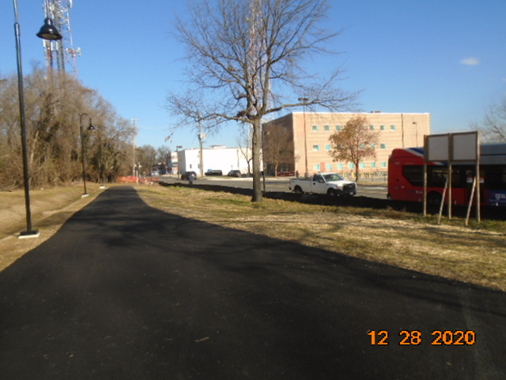
Phase B – No work performed

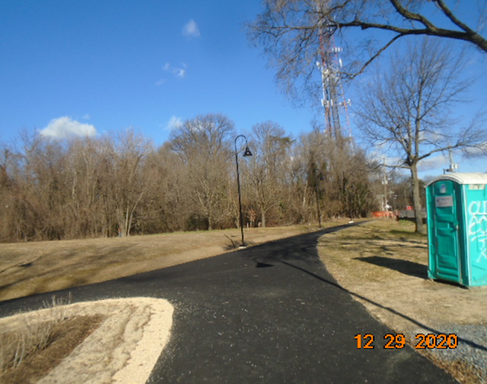
Phase B – No work performed
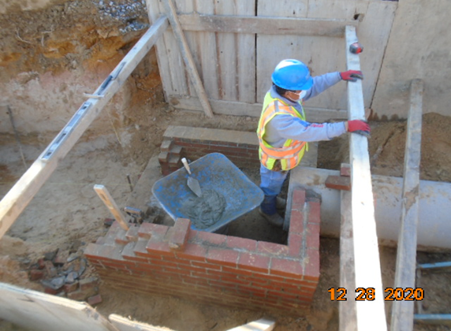
Phase D – Crew constructing brick manhole

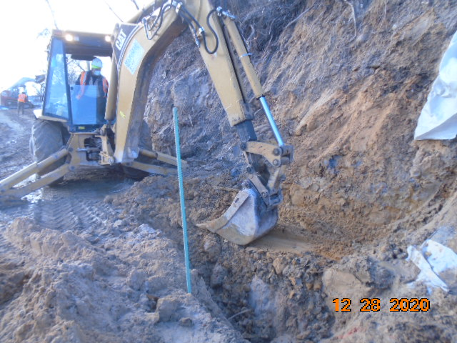
Phase D – Crew excavating retaining wall footing

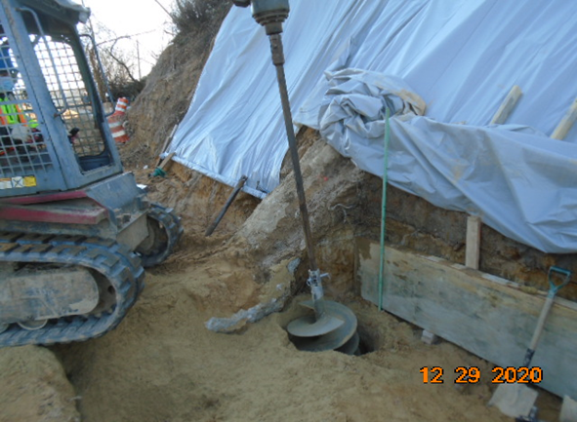
Phase D – Crew shaft drilling retaining wall S2 foundation

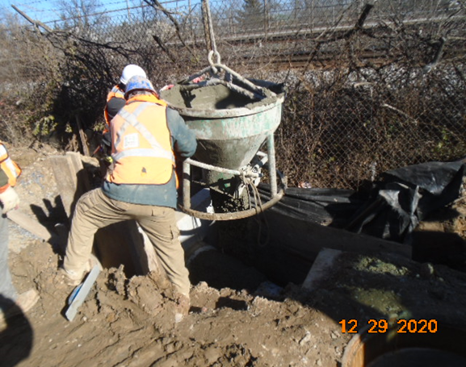
Phase D – Crew placing cradle concrete

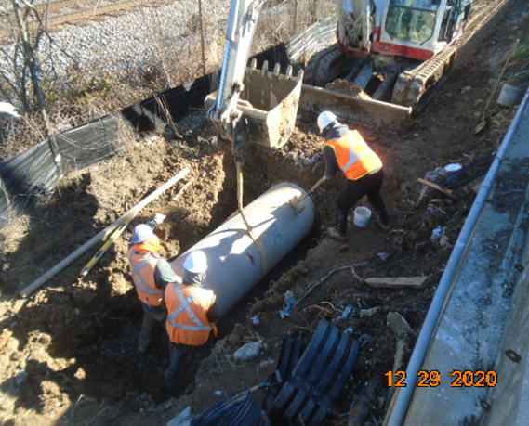
Phase D – Crew installing drainage pipes

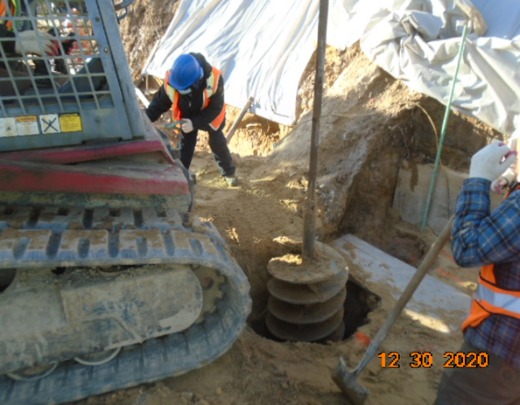
Phase D – Crew shaft drilling retaining wall S2 foundation

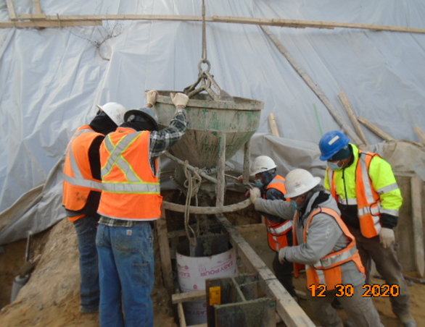
Phase D – Crew placing drilled shaft concrete

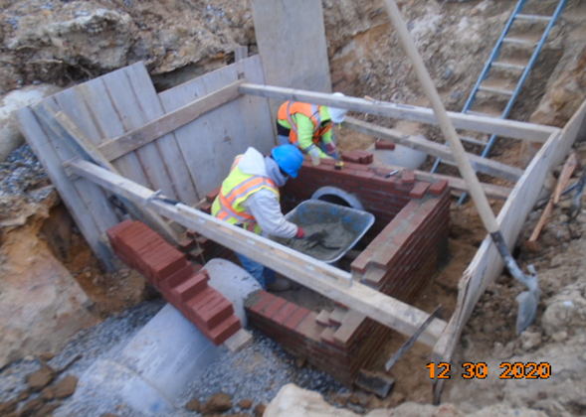
Phase D – Crew constructing brick manhole

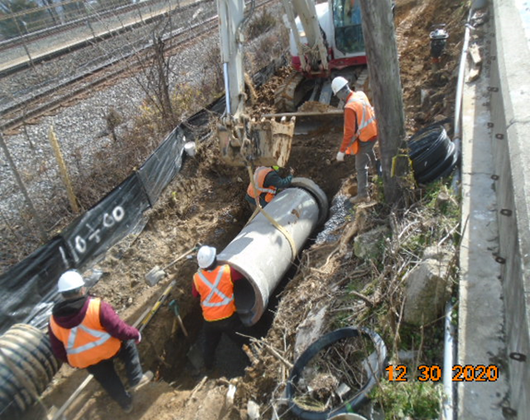
Phase D – Crew installing drainage pipes

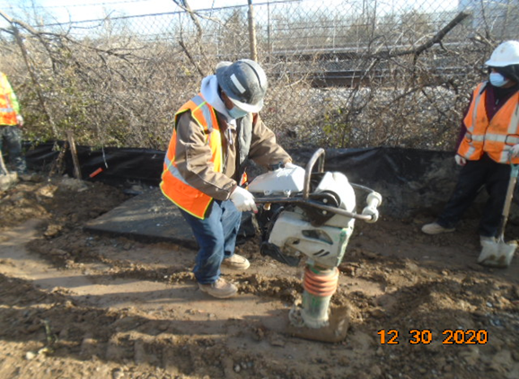
Phase D – Crew compacting drainage trench

