Metropolitan Branch Trail Design Build, South Segment
DC CONTRACT NO. DCKA-2016-C-0044
FAP No.: STP-2016 (060)

CONSTRUCTION MANAGER’S
WEEKLY PROGRESS REPORT

12/26/2021 – 01/01/2022

Project Website: www.metbranchtrail-forttotten.com
For Additional Trail Information Please see www.metbranchtrail.com
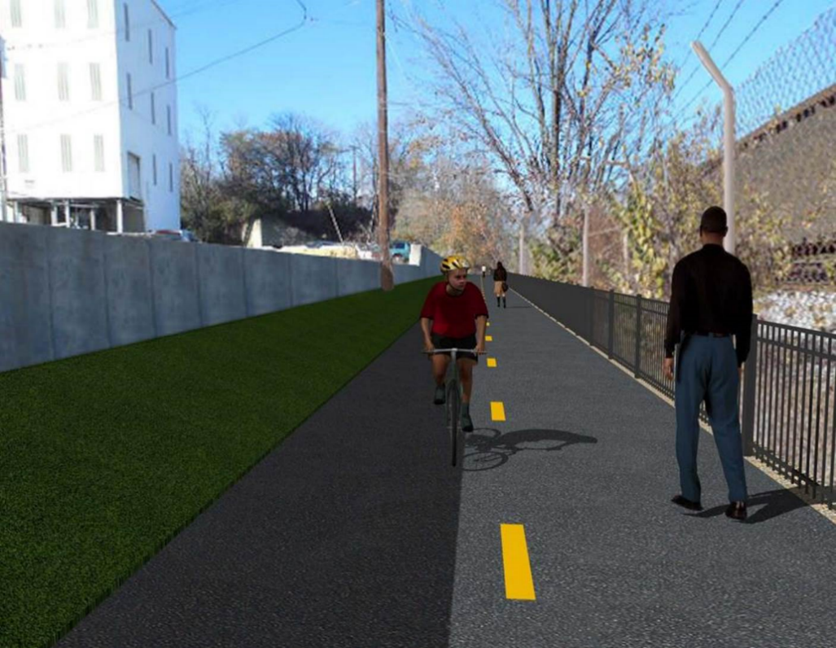

Proposed Metropolitan Branch Trail

1. PROJECT DESCRIPTION

The planned Metropolitan Branch Trail Project (“the Project”) consists of the design and construction of a new trail adjacent to CSX tracks and WMATA Red Line tracks along John McCormack Drive, adjacent to Fort Totten Metro Station, and on NPS property in NE, Washington D.C. The trail begins approximately 1500 feet south of Bates Road NE on the east side of John McCormack Drive NE, extending north along the WMATA and CSX tracks to the Fort Totten Metro Station tie in with First Place NE. An existing trail connection from Gallatin Road NE to the Fort Totten Metro Station will be reconstructed as a part of the Project.

The Project is 83.15% Federally-Funded and 16.85% District-Funded. Potomac Construction is the Design Build contractor.

Delon Hampton and Associates Chartered is providing Construction Management and Inspection services. Specific Construction Scope of Work includes:

- Provide mobilization and demobilization, provision and maintenance of Engineer’s field facilities, field layout, employee training, and other incidental work required for a quality, complete and finished product;
- Establishment and maintenance of vehicular and pedestrian traffic including signs, barricades and other transition devices; reconfiguring the devices in conjunction with changes in work areas; and their removal and disposal upon project completion, including restoration of disturbed areas;
- Clearing and grubbing, as required within the LOD;
- Removal of unsuitable material, excavation, and backfilling and pervious paving to construct a new trail;
- Protection of trees during construction;
- Provide ADA compliant trail connections and pedestrian ramps;
- Provide retaining walls as necessary to stay within the LOD and minimize property impacts following visual requirements specified for retaining walls on NPS property;
- Provide new permanent regulatory and wayfinding signs for the trail and all trail connection intersections;
- Provide road and trail pavement markings;
- Provide landscaping within the LOD for the Project including special requirements for landscaping on NPS property;
- Provide erosion and sediment control measures, storm water management facilities, including pervious asphalt pavement and bioretention facilities;
- Provide utility coordination, identification, locating, and protection of all utilities encountered during design and construction including relocation of Pepco poles along Aggregate Industries property; and
- Provide new WMATA security fencing between the trail and CSXT tracks.
- Remove existing sidewalk and widen sidewalk to 10’ along the west side of 1st place NE from Metropolitan Branch Trail to entrance to WMATA bus loop, on the west side.

2. STATUS OF CONSTRUCTION / PROGRESS SUMMARY

Work performed this week:

Design

- 100 % Complete

Construction:

Phase D

- Excavated drainage trench
- Installed drainage pipes
- Backfilled and compacted drainage trench
- Installed WMATA Stair rebar
- Constructed WMATA Stair formwork
- Placed WMATA Stair concrete
- Excavated and graded concrete ditch subgrade
- Compacted concrete ditch subgrade
- Placed concrete for concrete ditch behind S3 wall
- Graded embankment slope area behind S3 wall
- Cleaned and fine graded slope area located between PCC curb and AI chainlink fence
- Installed erosion control mat and seeded slope area adjacent to CSX fence
- Installed erosion control mat and seeded slope area behind S3 wall
- Seeded slope area behind S3 wall
- Contractor safety tool box talk

CM Consultant:

- Monitored construction progress, make sure all applicable inspections and testing were performed
- Reviewed Project Schedule
- Prepared CM Weekly Report to post
- Prepared CM weekly report to DDOT
- Updated Project Files
- Updated Project Logs
- Updated Project Webpage
- Updated documents in DHA SharePoint site
- Updated DDOT Sharepoint site
- Communication with PCCI and stakeholders in terms of submittals

3. MEETINGS / PROJECT COORDINATION

None during this week.

4. DAILY WORK PERFORMED

Sun 12/26/21 No work performed.
Mon 12/27/21 Phase D – Installed WNMATA Stair rebar. Constructed WMATA Stair formwork.
Excavated and compacted concrete ditch behind S3 wall. Constructed concrete ditch formwork. Placed ditch concrete. Reset drainage manhole. Cleaned and graded slope area located between PCC curb and AI property fence. Installed erosion control mat over slope along CSX fence. Dug holes for trail sign posts.
Phase D – Electrical work – No work performed.
Tue 12/28/21 Phase D – Constructed concrete ditch formwork.
Excavated and graded slope area behind S3 wall. Installed erosion control mat.
Placed rip rap stone at the drainage end section. Constructed brick channel
inside drainage manhole. Reset drainage manhole.
Phase D – Electrical work – No work performed.
Wed 12/29/21 Phase D – Placed ditch concrete behind S3 wall. Excavated drainage trench. Installed drainage pipes. Backfilled and compacted drainage trench. Excavated and graded slope area behind S3 wall. Installed erosion control mat behind S3 wall. Seeded slope area behind S3 wall. Cleaned and graded slope area behind PCC curb.
Phase D – Electrical work – No work performed.
Thurs 12/30/21 Phase D – Work canceled due to rain.
Phase D – Electrical Work – No work performed.
Fri 12/31/21 Phase D – New Year Holiday.
Phase D – Electrical Work – No work performed.
Sat 01/01/22 Phase D – No work scheduled.

5. INSPECTION & MATERIAL TESTS PERFORMED

Jobsite Safety Inspection  Erosion and Sediment Control inspection  MOT Inspection  Compaction Test  Asphalt Material Testing  Concrete Material Testing – Results pending  ** Note - Additional Material Test Results can be found on DDOT QA QC Material Division Tracking SharePoint website. | Infiltration Tests  Dynamic Cone Penetration (DCP) Tests  Rebars Inspection - Passed
6. DBE PARTICIPATION SUMMARIES

Potomac Construction Inc. (Contractor)

- DBE Goal for Contractor is 15%. To-date the Contractor has achieved 55% of their goal.

Delon Hampton & Associates (CM)

- DBE Goal for the CM is 10%. To-date the CM has achieved 102 % of their goal.

7. ACCIDENTS / INCIDENTS

None occurred on-site during this week.

8. PHOTOS OF THE WORK PERFORMED

12. PHOTOS OF WORK PERFORMED THIS PERIOD

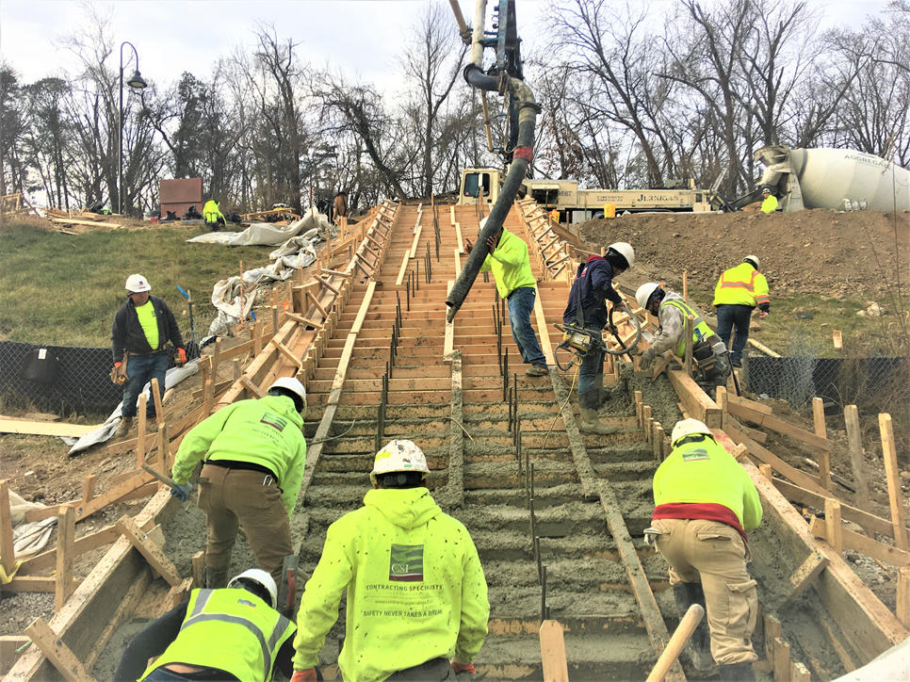
Phase D – Crew placing WMATA Stair concrete

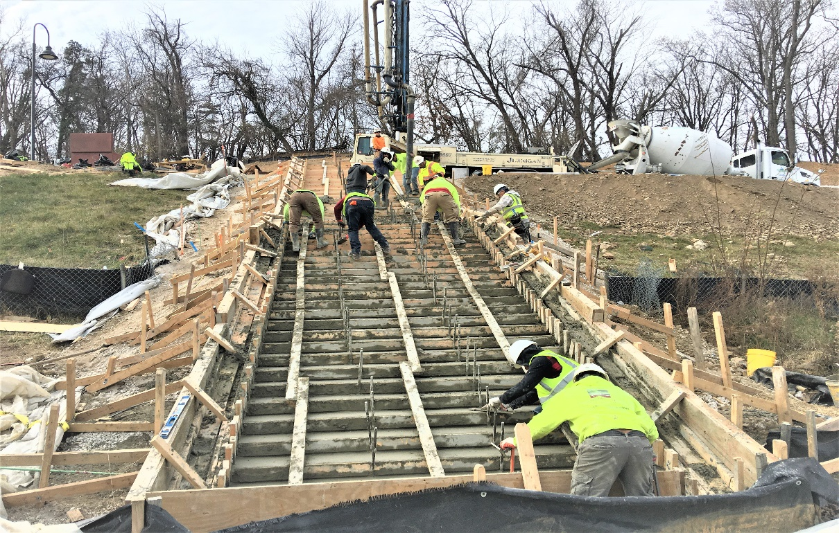
Phase D – Crew finishing WMATA Stair concrete

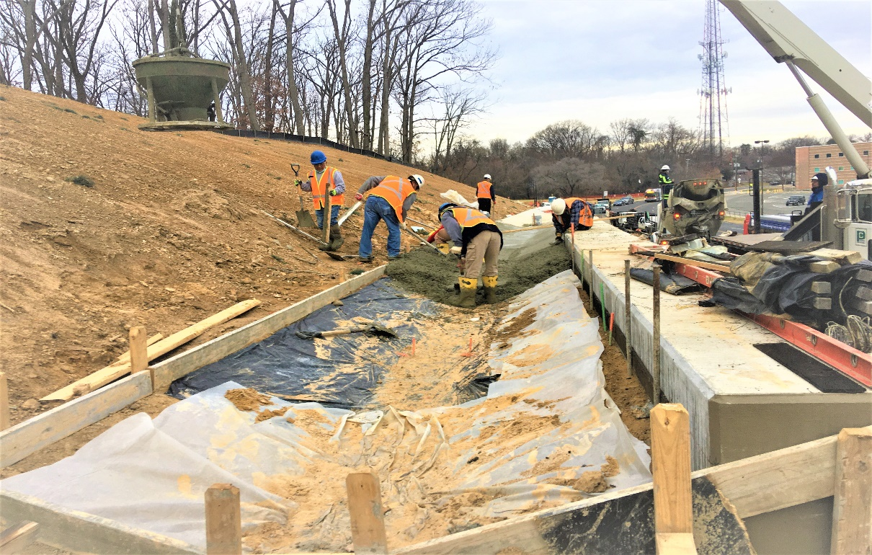
Phase D – Crew placing concrete for the concrete ditch behind S3 wall

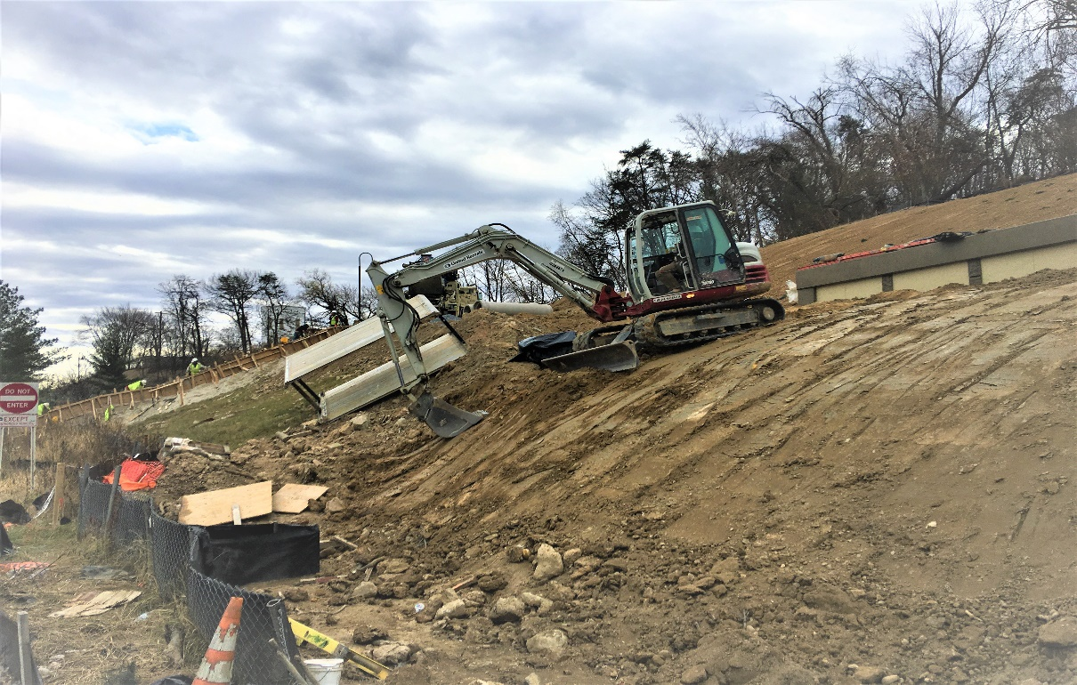
Phase D – Crew grading embankment slope along the trail in front of S3 wall

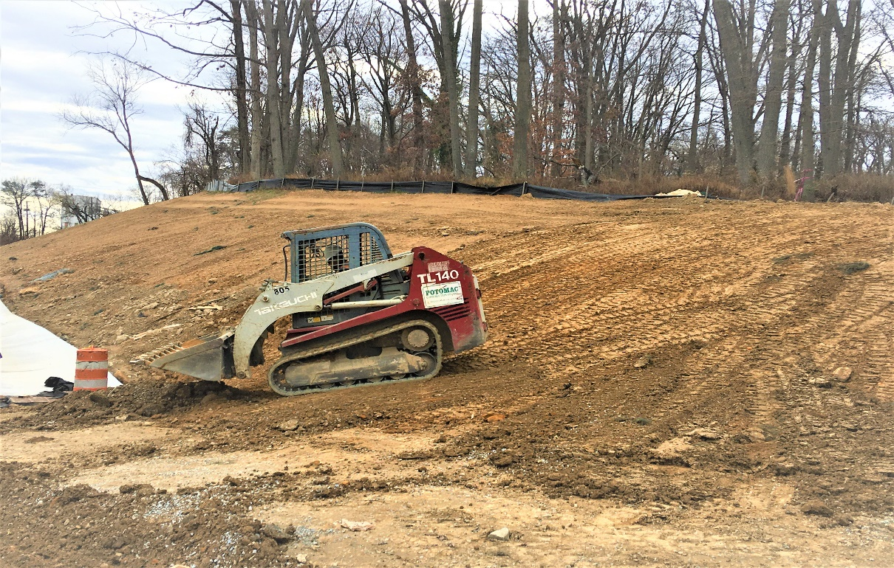
Phase D – Crew grading slope area behind S3 wall north end

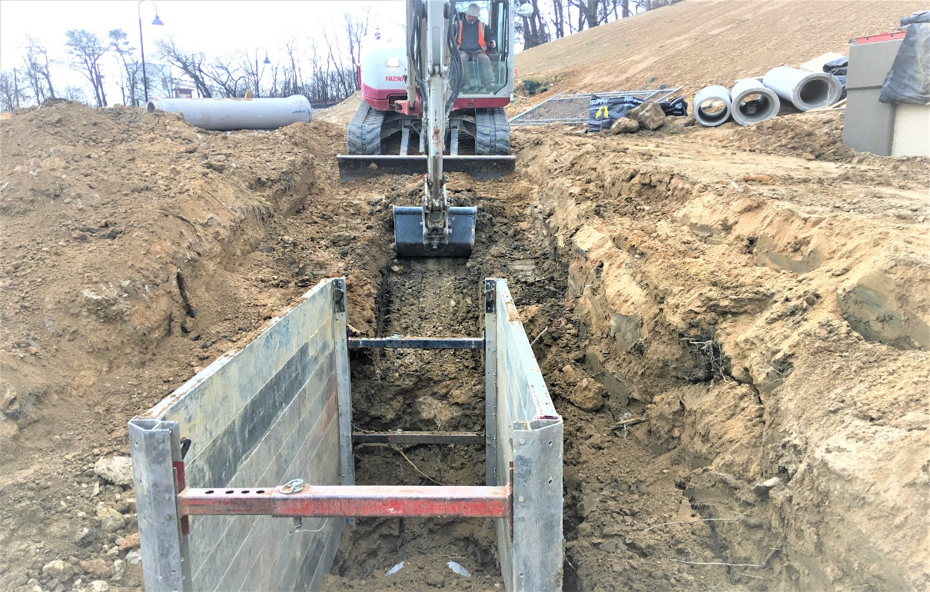
Phase D – Crew excavating drainage pipes trench

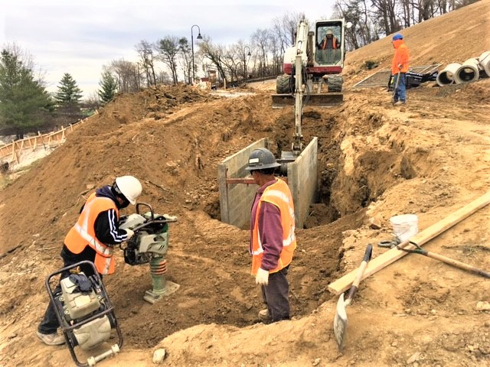
Phase D – Crew compacting drainage trench

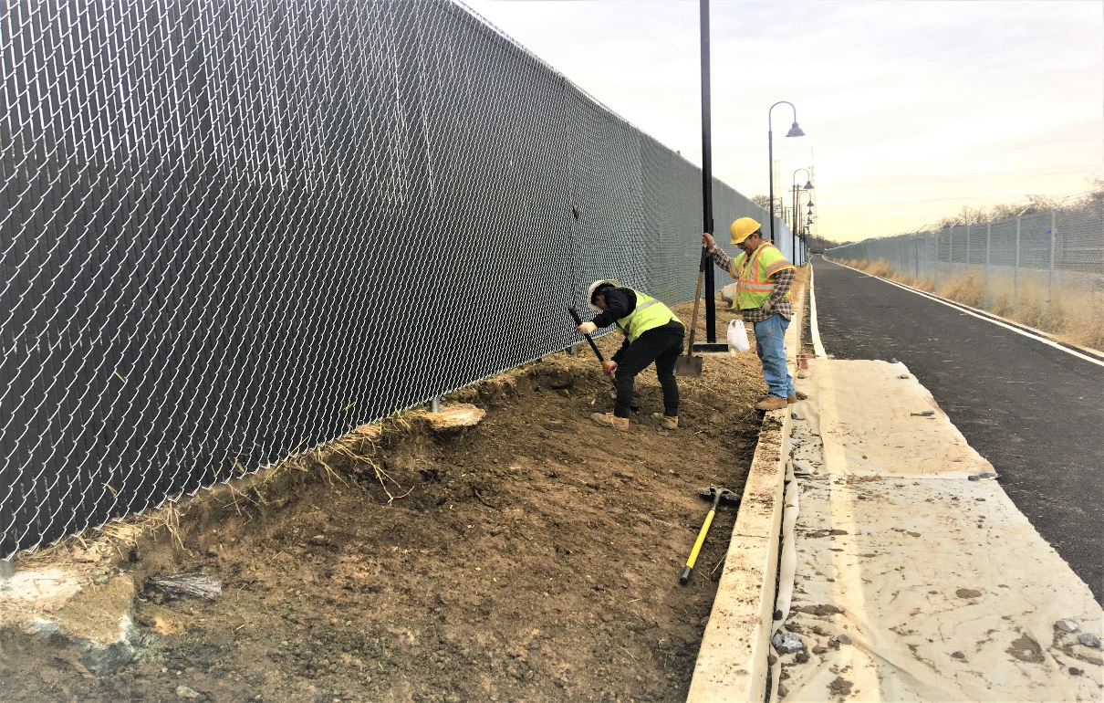
Phase D – Crew cleaning and fine grading slope area along PCC curb

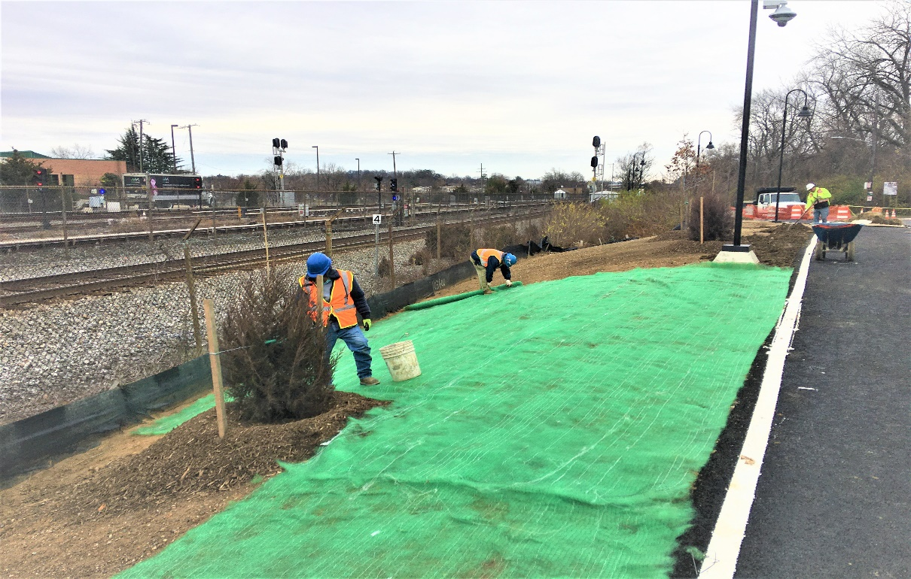
Phase D – Crew installing erosion control mat over slope area along CSX fence

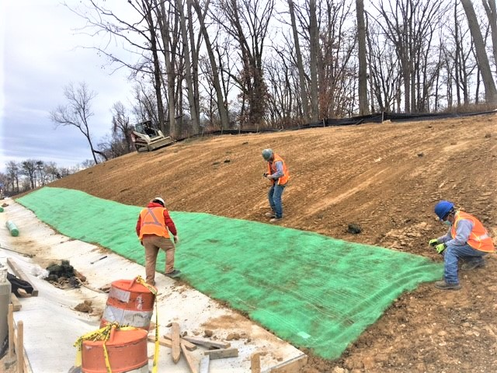
Phase D – Crew installing erosion control mat over slope area behind S3 wall

